TAWA COMMUNITY BOARD

SUBMISSION TO THE WELLINGTON CITY COUNCIL ON THE 2006 REPRESENTATION REVIEW

Friday, 31 July 2026

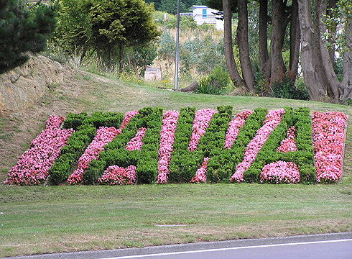

INDEX

INTRODUCTION 3
The Tawa Community Board (TCB) submits 4
DID YOU KNOW… 5
The Tawa community of interest is distinct and unique in Wellington resulting from a combination of many features including: 6
Category a – easily definable geographical area 6
Category b – a strong dependence on shared facilities 6
Category c – a defined town/community centre 7
Category d – a long history as a community separate from Wellington 7
Category e – a strong sense of community identity and belonging 7
Category f - major transport routes (SH1 and main trunk line) run through the community 8
Category g – unique facilities 8
Category h – a cohesive sense of being a town in its own right 8
Conclusion 8
The Tawa Community comes under the ambit of several vital organisations that other suburbs in Wellington may not. 9
• Police 9
• Fire 9
• Health 9
• Civil Defence 9
The Board is an important link in the democratic process serving as a conduit from the people of Tawa to the Council and from the Council to the people of Tawa. 10
Background 10
Current Public Participation in the Democratic Process 10
Other operational obligations on the TCB 10
Conclusion 10
The review of community boards undertaken by the Council as part of this representation review: 12
Full review of community boards city wide 12
Other options: 12
But is it fair that Tawa has a community board and other suburbs don’t? 13
Effective representation 13
Implications of abolishing the TCB 13
Impact on involvement of Tawa people in the democratic process 15
Conclusion 15
The Tawa Community of 14,500 people makes up over 34% of the Northern Ward population of 42,400. If the Council’s proposal is adopted, the Northern Ward will be the most under-represented Ward (1:14,133). Therefore, the existence of a Board in Tawa is a valid mechanism for addressing this level of under-representation at Council level. 16
Representation levels in Tawa since 1989 16
Current Tawa representation levels 16
CONCLUSIONS 17

INTRODUCTION

Section 10 of the Local Government Act 2002 (LGA) states that the purpose of local government is:

- to enable democratic local decision-making and action by, and on behalf of, communities; and

- to promote the social, economic, environmental and cultural well-being of communities, in the present and for the future.

And, under Section 14 of the LGA, the WCC should:

- make itself aware of, and have regard to, the views of all of its communities; and

- when making a decision, take account of:

(i)the diversity of the community, and the community's interests, within its district or region;

(ii)the interests of future as well as current communities; and

(iii)the likely impact of any decision on each aspect of well-being referred to in section 10:

Therefore, when undertaking a representation review, the Wellington City Council (WCC) must be mindful of the above statutory obligations.

The Tawa Community Board (TCB) is concerned that the WCC is not of the view that the Tawa Community is a community of interest (in terms of representation purposes) and believes that insufficient regard has been taken of Section 14(2) of the LGA when reaching its initial proposal to abolish the Tawa Community and the TCB.

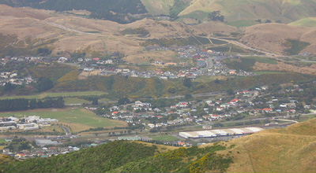

View of Tawa from Collins Ave in the north (at left) to Duncan St at right. The red-roofed buildings at left are Linden School. The Intermediate School and College can be clearly seen in the centre of this shot, along with the College's 'top fields' above the row of trees. To the right of that, and moving up a little, is the southern end of Woodman Drive with its newish housing. Behind that is the new road heading up the hill.

The Tawa Community Board (TCB) submits

that it opposes the Wellington City Council’s initial proposal to abolish the Tawa Community and the TCB because:

- The Tawa community of interest is distinct and unique in Wellington resulting from a combination of many features including:

  - An easily definable geographical area;
  - A strong dependence on shared facilities including schools, churches. recreational and cultural facilities, medical and other professional services and retail outlets;
  - A defined town/community centre;
  - A long history as a community separate from Wellington;
  - People who live here have a strong sense of community identity and belonging;
  - Major transport routes (SH1 and the main trunk railway line) run through the community;
  - Unique facilities; and
  - A cohesive sense of being a town in its own right.

- The Tawa Community comes under the ambit of several vital organisations that other suburbs in Wellington may not. For example:

  - the Kapi-Mana Police District, not the Wellington District;

  - Tawa has its own Fire District.

- The TCB provides effective representation for the Tawa community.

- The TCB is an important link in the democratic process serving as a conduit from the people of Tawa to the Council and from the Council to the people of Tawa.

- The review undertaken by the Wellington City Council (WCC) as part of this representation review:

  - was not a full review of community boards as it agreed at its meeting on 23 October 2003 and noted by the Local Government Commission in its determination; and
  - did not adequately consider the implications of abolishing the TCB.

- The Tawa Community of 14,500 people makes up over 34% of the Northern Ward population of 42,400. If the Council’s initial proposal for Ward representation is adopted, the Northern Ward will be the most under-represented Ward with 1 councillor to every 14,133 voters. Therefore, the existence of a Board in Tawa is a valid mechanism for addressing this under-representation at council level.

DID YOU KNOW…

- Tawa, along with Porirua and Titahi Bay, was part of Makara County until the Tawa Borough Council was formed in 1953 to administer Tawa Flat and Linden.

- On 23 February 1959, Tawa Flat and Linden became formally known as Tawa.

- The 1989 amalgamation saw 4,058 rateable properties and 86 non-rateable properties with a gross capital value of $398,348,938 transferred into the WCC rating area.

- In the year to 31 March 1990, the Tawa Borough Council received $3,836,049 in rates. The regional council levied a further $729,105 .

- Assets built and paid for by the Tawa Community that transferred to WCC included:

  - A swimming pool;

  - A library;

  - Pensioner housing;

  - Several community halls including the Linden Social Centre; and

  - Administrative offices.

In the 2006/07 financial year 4834 Tawa ‘rate accounts’ will pay over $8,500,000 in rates to the Council so:

Tawa is a valuable economic and financial asset to WCC and

Tawa, even with its Community Board, is NOT a financial burden on other suburbs or communities of Wellington.

The Tawa community of interest is distinct and unique in Wellington resulting from a combination of many features including:

  - An easily definable geographical area;
  - A strong dependence on shared facilities including schools, churches, recreational and cultural facilities, medical and other professional services and retail outlets;
  - A defined town/community centre;
  - A long history as a community separate from Wellington;
  - People who live here have a strong sense of community identity and belonging;
  - Major transport routes (SH1 and the main trunk railway line) run through the community;
  - Unique facilities; and
  - A cohesive sense of being a town.

As well as the unique features mentioned above, the Local Government Commission guidelines (that were quoted in the Council’s public discussion document dated April 2006) indicated that a community of interest is:

“the area to which one feels a sense of belonging and to which one looks for social, service and economic support. Geographical features and the roading network can affect the sense of belonging to an area. The community of interest can often be identified by access to the goods and services needed for everyday existence.”

Although many other suburbs in WCC can also claim it has many of the above features, the TCB submits that Tawa is the only suburb/community in Wellington to have ALL of these features.

Category a – easily definable geographical area
- Tawa is entirely and physically separate from every other suburb in Wellington
- Tawa’s developed areas are surrounded by open, undeveloped areas to the east, west and south

Category b – a strong dependence on shared facilities
- Tawa has a wide range or facilities and services including:
  - Educational facilities – a college, an intermediate, 6 primary schools, numerous early childhood and child care centres
  - Recreational and cultural facilities – indoor recreation centre (at the college), sports grounds, sports clubs, amateur theatre group, music school, line dancing, yoga. Tawa even has its own orchestra!
  - Medical and professional services – including 2 medical centres, dentists, lawyers, accountants, chemists, optician
  - Numerous retail outlets including a supermarket and DressMart
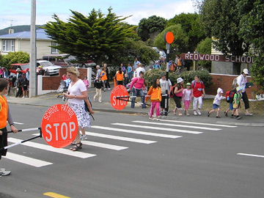
End of the day at Redwood School

Category c – a defined town/community centre
- The Tawa Shopping Mall and Main Street houses numerous shops and services and is a focus for both locals and people from other suburbs, primarily Johnsonville and Churton Park
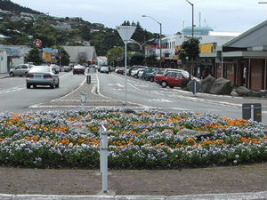

Category d – a long history as a community separate from Wellington
- Since its beginnings in the middle of the 19th century, Tawa remained a separate entity from Wellington until its 1989 amalgamation
- The first ‘council’ was elected in 1854 and, in 1876; Tawa Flat became part of the Porirua Riding of Hutt County.
- Tawa became part of Makara County in 1908 until 1951 when the Town Board was formed. Borough status was granted in 1953 and the Tawa Borough Council was created.
- Tawa was the last suburb to come into the domain of the WCC

Category e – a strong sense of community identity and belonging
- People who live in Tawa feel a real affinity for the community and a sense of belonging
- High membership rates of local sport and social groups indicate people’s commitment to being part of the community – they want to contribute. The recent Tawa Civic Awards attest to the high levels of participation in voluntary groups operating in Tawa
- A very high percentage of the children living in Tawa attend local Tawa schools

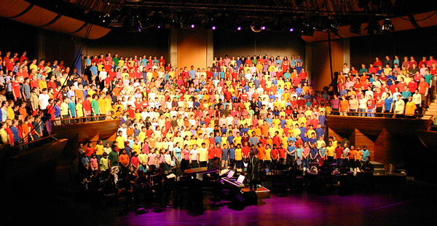
Most of the 900-strong choir at the Tawa Schools & Community Music Festival

Category f – major transport routes (SH1 and main trunk line) run through the community
- Tawa is bisected by the motorway and the railway line which creates a unique set of issues eg numerous railway crossings, traffic noise, local fire services called on to attend emergency situations
- The main Transmission Gully intersection will be in Tawa

Category g – unique facilities
- DressMart outlet shopping centre
- Jointly owned and managed recreation centre at Tawa College
- Arohata Prison at the southern end of Tawa
- Grenada North which is a fast developing industrial, storage and distribution area
- Takapu Valley is a large rural area that covers more than half of the TCB area

Category h – a cohesive sense of being a town in its own right
- Due to its history and geographical situation, Tawa can rightfully claim that it is a town in its own right.

Conclusion

The Tawa Community meets all the currently accepted criteria used to define a community of interest.

And, because the Tawa community of interest is so convincingly definable, the Tawa Community warrants representation through a Community Board

The Tawa Community comes under the ambit of several vital organisations that other suburbs in Wellington may not.

Police
  - Tawa is not part of the Wellington Police District and falls under the District Commander for the Kapi-Mana District
  - Tawa has a dedicated community constable
  - Tawa does not have a police station but does have a volunteer group who man an office

Fire
  - Tawa has its own Fire District so is separate from both Wellington and Porirua
  - Tawa has a fire station and a strong volunteer fire brigade who are often called upon to attend emergencies outside the Tawa area

Health
  - Although sited in Porirua, Kenepuru Hospital is 5 minutes from Tawa and is the first port of call for emergency admissions, births, and minor surgery for Tawa people
  - Numerous people who work at Kenepuru Hospital live in Tawa

Civil Defence
  - Tawa has four CD centres
  - Tawa has its own Urban Search and Rescue Team (USAR) Team

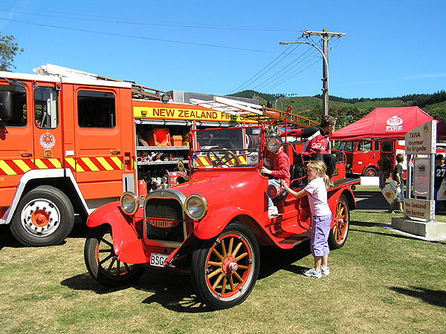

At the Fire Station Open Day

The Board is an important link in the democratic process serving as a conduit from the people of Tawa to the Council and from the Council to the people of Tawa.

Background

The Tawa Community Board has existed since 1989. The Community Board meets monthly to formally deal with issues that need decision at such meetings. As far as we are aware decisions made by the Board on local matters delegated to it are of a high quality. These are local decisions made locally with local knowledge, a fundamental principle of good management.

Two WCC Councillors are appointed to the TCB and at least one of them is always in attendance at TCB meetings. This is greatly appreciated by the TCB who have the chance to obtain information first-hand about matters affecting Tawa but it also provides the councillors with an opportunity to report back directly to their electorate.

Current Public Participation in the Democratic Process

The Board meetings are well attended by the public with local people or groups taking the opportunity to address the Board through the public forum opportunity. The meetings are often attended by the local press and reported in the media. It should be noted that both public and press attendance and use of the public forum at the TCB meetings show the effective way the TCB is connected with its constituency and the way its constituency uses it to air its concerns.

TCB meetings are held in the evenings which enables people who are unable to take part in the democratic process during the day time (because of work commitments), to participate.

Other operational obligations on the TCB

As well as its formal meetings, the TCB formally appoints members to represent the WCC on external organisations, such as the Elsdon Camp and Spicer Landfill Liaison Group.

The Chair and one other member of the TCB are also trustees of the Tawa Borough Scholarship Award Trust.

Three members of the TCB make up the Tawa Community Board Grants Sub-committee which meets annually to allocate $10,000 per annum. A member of the TCB is also appointed as a member of the Tawa College Community Education Advisory Committee.

In their private capacity, board members are involved in numerous groups throughout Tawa ranging from coaching school sport teams to being members of service groups. All the board members are therefore ‘out and about’ in the community on a regular basis and keeping in touch with the views of the people on the ground.

Conclusion
The abolition of the TCB will result in a reduction in the ability to achieve effective representation and a reduction in public involvement in the democratic process. This is because it is highly unlikely that any council or committee meetings will be held in Tawa.

WCC meetings tend to be held during working hours and, together with the fact that attendance involves at least a half hour car trip from Tawa (or even longer if public transport is used) means that it would be unlikely that Tawa residents will make the journey for three minutes speaking time. This lack of participation would be a sad reduction in public involvement in the democratic process.

The TCB also submits that reporting back by councillors to the Tawa Community would also be severely curtailed if the TCB was abolished.

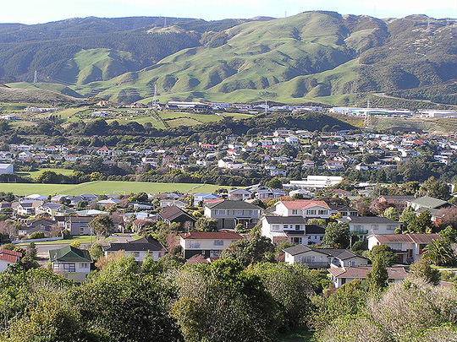
View from partway up the Brasenose Track (southwest Tawa) looking in the direction of Redwood Park and Redwood School. Foreground houses are in Greyfriars Cres and Oriel Ave. Middle background houses are Taylor Tce way. Beyond that, lifestyle blocks in Bing Lucas Drive. Industrial buildings at right are in Grenada North.

The review of community boards undertaken by the Council as part of this representation review:

- was not a full review of community boards citywide as it agreed at its meeting on 23 October 2003; and

- did not adequately consider the implications of abolishing the Tawa Community Board.

Full review of community boards city wide

The TCB understands that the Council agreed, during the representation review process in 2003, to conduct a full review of community boards city wide. The TCB contends that the review of community boards undertaken as part of the representation review was not as thorough or as open as it could have been.

The TCB submits that:

- A full review would have involved both of the existing boards to a far greater extent than they were.

- The report 6 dated 15 June 2006 to the Strategy and Policy Committee included commentary on the visit of 3 councillors and 1 official to Auckland and Christchurch to assess the operation of boards in those areas. However, this feedback did not include some vital information that the TCB suggests may put a different slant on the report back. For example:

- both of these cities are significantly larger than Wellington in terms of population (380,154 in Auckland and 324,297 for Christchurch);
- the number of councillors (20 in Auckland and 12 in Christchurch) and the number of wards;
- both of these cities have community boards across the city;
- the population of the communities the boards represent – in Christchurch, the boards represent communities of over 40,000 people

The TCB would also suggest that the representation arrangements of these two city councils are so different from Wellington that there is no point in using them as a benchmark when reviewing community boards in Wellington.

Other options:

Although the Council considered a number of variations of representation involving community boards, the TCB believes that other valid options were not pursued. For example:

- Reducing the number of councillors per ward and having a community board or boards in each ward;
- Amalgamating the Makara-Ohariu and Tawa Boards;
- Amending the boundaries of the Tawa board to incorporate Grenada North and Newlands (a community/suburb that lobbied for its own board during the 2003 representation review process); or
- Abolishing the Tawa Board and creating a Northern Ward-wide board.

But is it fair that Tawa has a community board and other suburbs don’t?
Two basic points to note are:

- that the Tawa Community has always had some level of separate representation arrangement; and
- other suburbs are perfectly entitled to seek representation via community boards under the existing legislation.

Section 19V(2) of the Local Electoral Act (LEA) addresses the issue of fair representation but the TCB believes the criteria of fairness is only relevant in the context of ensuring that the number of electors per ward is comparable if a council decides to elect its councillors on a per ward basis.

In terms of the LEA, the TCB does not believe that ‘fairness’ by itself is a consideration when determining whether or not a community should or shouldn’t be represented by a community board.

If ‘fairness’ is being used in a moral sense or in the sense of equity across the city, then the TCB submits that:

- equity does not necessarily mean being the same – some parts of Wellington may not wish to be represented at a Board level but that shouldn’t mean that existing boards should be abolished or changed or new ones created if that is the wish of their community;
- it appears that the WCC is proposing to reduce all areas to the same level and is not recognising the differences that make up communities and communities of interest. The WCC has decided that because not all parts of Wellington say they want a board, no one can have one.

The TCB has reason to believe that the people of Tawa wish to retain their community board and that Tawa has a sufficiently strong claim to have one because of its definable community of interest.

The TCB does not believe that the issue of ‘fairness’ is a valid, legal reason for abolishing the current board or, for that matter, denying other communities the right to have one if they so wish.

Effective representation

The LEA also refers to effective representation and the TCB believes that this criteria in conjunction with the fairness principal, does apply when considering the creation or abolition of a community board.

The TCB submits that a board for the Tawa Community is an effective mechanism for ensuring the WCC meets its obligations under the LGA to ensure that democratic local decision-making and action by, and on behalf of, communities occurs and that the social, economic, environmental and cultural well-being of Tawa, in the present and for the future, is promoted.

Implications of abolishing the TCB

We have been unable to find any documentation analysing the effect of the council's decision to abolish the TCB. As we see it, there will be a number of quite serious effects not just on the Tawa community but also on the WCC and councillors. These effects include:

Costs

We believe that the abolition of the TCB will have little effect on direct costs.

- The salaries of councillors and community board members are paid from a pool set by the Remuneration Authority with 50% of community board salaries met from rates. The amount of TCB salaries met from rates is approximately $27,000 per year. Whether the Remuneration Authority would reduce the pool if the TCB is abolished is not known but it is a possibility that is may not.

- Even if there were to be savings made on salaries paid from the rates, we believe that numerous additional costs would arise to ensure that the current level of engagement with Tawa is maintained. A primary example would be the additional travel and salary costs that would have to be met if the Council (elected and official members) are to comply with its Consultation Policy when dealing with issues affecting Tawa.

This increase in travel costs and lost time could also occur if more council meetings and committee meetings were held in Tawa to enable public participation to occur more effectively with councillors from the other Wards having to travel to Tawa.

Decisions

The abolition of the TCB will also mean that any really local decisions would need to be made by councillors or officials.

- Decisions will therefore be made by people who are generally unfamiliar with Tawa and its issues. While there may be Northern Ward councillors present when some of these decisions are made, chances are they will be in the minority and not able to reflect the range of views available when the TCB is involved when any such decisions are made.

- The TCB is closer to the Tawa community and has more information about local issues and may be better informed than the council as a whole so, the decisions on local Tawa issues or issues that impact on Tawa will necessarily be less informed and probably poorer quality decisions.

Workload

Decisions will of course still have to be made but, if the TCB is abolished, councillors, officials and possibly even consultants will have to become more actively involved in directly consulting the Tawa community.

- If the level of involvement of the council with the Tawa community is to be retained, all the other activities currently carried out by Board members will have to be carried out by the councillors in addition to their existing council duties.

- Delegating responsibility to or involving the TCB in the local decision-making frees up councillors so they can focus on strategic district or city wide issues without the distraction of much operational detail. They could spend more time on the more complex policy issues confronting their city as a whole.

- We believe the TCB is an effective mechanism for reducing workloads on Councillors. We would therefore suggest that community boards across Wellington city need to be seriously considered.

Impact on involvement of Tawa people in the democratic process

The additional travel commitment required to be involved in the democratic process would have two effects on the people of Tawa:

- it may preclude people from standing for election at all. Some may be able to fit in the time for meetings but the extra commitment of travel time in addition would make seeking election out of the question for some. In contrast, election to the TCB involves a lesser time commitment while still allowing participation in the democratic process.

- The distances involved in travel to Wellington from Tawa also affect the ability to achieve effective representation and the equal opportunity for all persons to accept nomination as candidates.

- The travel to Wellington would also affect a Tawa resident's ability to participate in the public forum session of meetings. This opportunity is well-used in Tawa with a number of members of the public or community groups taking the opportunity to use the public participation section of the meeting to raise issues of concern. In some cases, members of the public are also invited to the table to take part in discussion about a particular agenda topic.

Conclusion

The TCB does not believe that the WCC has adequately reviewed the issue of community boards citywide, possible alternatives or the consequences of its initial decision to abolish the Tawa Community and TCB.

The Tawa Community of 14,500 people makes up over 34% of the Northern Ward population of 42,400. If the Council’s proposal is adopted, the Northern Ward will be the most under-represented Ward (1:14,133). Therefore, the existence of a Board in Tawa is a valid mechanism for addressing this level of under-representation at Council level.

Representation levels in Tawa since 1989

- In 1989, Tawa had its own Council with a representation ratio of approximately 1:1,500 as well has having direct governance over its own affairs.

- From 1989 until the 1996 election, Tawa elected two councillors directly onto the Council with a representation ration of approximately 1:6,500.

- In 1993, the Tawa Ward was amalgamated into the Northern Ward thereby reducing the level of representation again. The representation ratio became approximately 1:13,000

- These current proposals, if adopted, will see Tawa’s level of representation diminish again. This time to 1:14,433

- Looking ahead, Tawa is developing rapidly with large numbers of new dwellings being built and two retirement villages being proposed. Both of these developments will significantly increase the population of the Tawa community so, if these proposals are approved, the representation levels for Tawa citizens at councillor level will just worsen.

Current Tawa representation levels
Comments have been made that members of the Tawa community can vote for and be represented by three councillors and six members of a Community Board and are therefore over-represented.

Over-representation is only an issue if it leads to problems or distortions in the decision-making process; the right to vote for more people isn't fundamentally a problem. There are two possible areas where there could be distortions: costs and undue influence on decisions. We do not believe either argument is valid in Tawa’s case.

The annual direct costs to run the TCB are $66,540, of which $54,500 is for salaries. It is important to note that Councillors’ salaries and half the salaries of community boards are met from a pool set externally by the Remuneration Authority.

The existence of the TCB does not create a bias in decision-making at Council level as the only decisions the TCB makes are on local Tawa issues or on a course of action when a city-wide decision impacts on Tawa. We do not believe either of these instances affects either district wide policy or issues arising in other Wards. The extra number of representatives merely results in decisions on local issues being made locally.

The TCB does not believe that ‘over-representation’ (if any) causes any adverse effects and is therefore it is not a valid argument to abolish the TCB.

CONCLUSIONS

- The Tawa community is physically quite separate from the rest of Wellington.

- The TCB functions well with good relations with the WCC. There are clear lines of delegation and local decisions are seen to be made locally. It is an effective unit delivering local government in the Tawa community. There is no sense of ‘them and us’.

- The abolition of the TCB will result in increased workload for councillors, probably poorer quality decision making in so far as it affects local Tawa issues, and less connection between local organisations and the council. There will also be local suspicion of decisions made in Wellington on Tawa matters.

- There will be reduced access to democratic processes due to the distance of the Tawa community from Wellington city, reducing the opportunity for election to office and attendances at meetings.

- There are no evident problems with the TCB and there do not appear to be any good reasons for, or clear benefits in, its abolition.

- The TCB is committed to working for a strong, successful, prosperous, vibrant Tawa now and in the future. One that has extensive community involvement in the democratic decision making process.

- We therefore seek the Council’s agreement to rescind its initial proposal to abolish the Tawa Community and TCB.

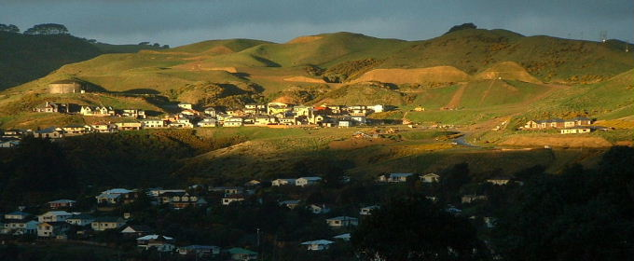
Late sun on the eastern hills of Tawa

Borough of Tawa Accounts and Statements for the Year ended 31 March 1990
STET
Email dated 3 August 2006 from Ross Bly, Wellington City Council

